There are two parts in this assignment.

**Part 1: Ruby Palms Zoo**Palms Zoo currently tracks its animals using a spreadsheet, and wants to upgrade to using a relational database. You have been tasked with this conversion, and need to convert this flat field design into a relational database design.

Ruby Palms Zoo has given you its current spreadsheet design, which contains the following fields (columns).

* Animal ID
* Animal Name
* Birth Date
* Acquisition Date
* Species Scientific Name
* Species Common Name
* Species Description
* Daily Food Need in Pounds
* Food Purchased Through Date
* Exhibit 1 Name
* Exhibit 1 Revenue
* Exhibit 1 Participated
* Exhibit 2 Name
* Exhibit 2 Revenue
* Exhibit 2 Participated
* Exhibit 3 Name
* Exhibit 3 Revenue
* Exhibit 3 Participated

Ruby Palms Zoo has also given you the following business rules, which are incomplete and are not all necessarily structural.

* The date animals are acquired by the zoo is recorded.
* Every animal has a species.
* Every species requires an average number of pounds of food per day.
* Food is purchased in bulk for each animal, and the zoo tracks how long the food will last for the animal.
* Three special fundraising exhibits are offered each year.
* Animals are selected to participate in the exhibits, and whether or not each animal participated in an exhibit is tracked.

1. To get started, create a complete list of business rules that you will use as a basis for your logical diagram. Your list of business rules should specify all entities, relationships, optionality constraints, and plurality constraints, and must make provision for the data and business rules given to you by Ruby Palms Zoo. There can be many solutions that correctly make provision for the given data and business rules.

**Each ANIMAL must be a member of one species; A SPECIES may contain one or more animals.**

**Each SPECIES may eat their allotment of food every day; FOOD may be eaten by 0 or more species.**

**FOOD may be purchased for one or more animals; each ANIMAL must have its food purchased for them.**

**Each ANIMAL may be selected to participate in 0 or more exhibits; each EXHIBIT may showcase one or more animals.**

2. Now create a *logical* entity-relationship diagram (ERD) that illustrates the relational database design described by the business rules in #1. All entities should be normalized to BCNF. Recall that logical ERDs contain SQL-based constraints on the attributes, including primary and foreign key constraints.

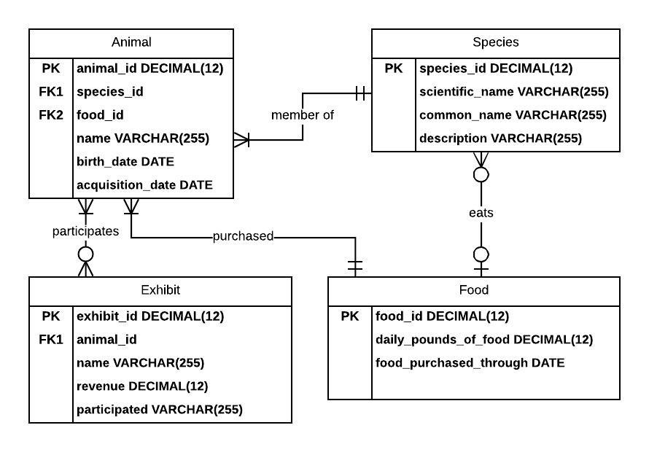

**Part 2: Food Establishments**The following incomplete list of business rules describe the relationships between some of the different types of food businesses available.

1. Restaurants can be diners, pizzerias, delis, or none of these.
2. Restaurants and grocery stores are food businesses, but not all food businesses are restaurants or grocery stores.
3. Some delis and pizzerias are take-out restaurants.
4. Some restaurants are sit-down only restaurants, but not all restaurants are sit-down only.
5. Supermarkets and supercenters are grocery stores, but not all grocery stores are supermarkets or supercenters.
6. Food manufacturers are food businesses, and can be canneries, packaging plants, both or neither.

All relationships described in these rules are specialization-generalization relationships. These rules also reflect the entities and relationships that exist in the real-world.

1. Create a complete list of business rules that are consistent with the incomplete list given above. Try to order the rules logically, either starting at the bottom of the hierarchy working upward, or from the top of the hierarchy working downward. This list should make provision for all entities and relationships given in the above list, and there can be many solutions that do so correctly.

**Restaurants can be diners, pizzerias, delis, or none of these.**

**A food business can be a restaurant, grocery store, or none of these.**

**Take-out restaurants can be deli’s, pizzerias, or none of these.**

**Restaurants can be sit down only restaurants, take-out restaurants, both, or none.**

**A grocery store can be a supermarket, supercenter, or none of these.**

**Food manufacturers are food businesses.**

**Food businesses can be canneries, packaging plants, both or neither.**

2. Develop an extended entity-relationship diagram (EERD) that illustrates the relational database design described by the business rules in #1. The diagram should include the primary key of each table in order to demonstrate correct implementation of specialization-generalization. While EERDs may well contain other attributes, in this assignment you need not include them because they are not described in the business rules. You should use legal database identifiers such as *Sit_Down_Restaurants* or *Food_Manufacturers* in your EERD.

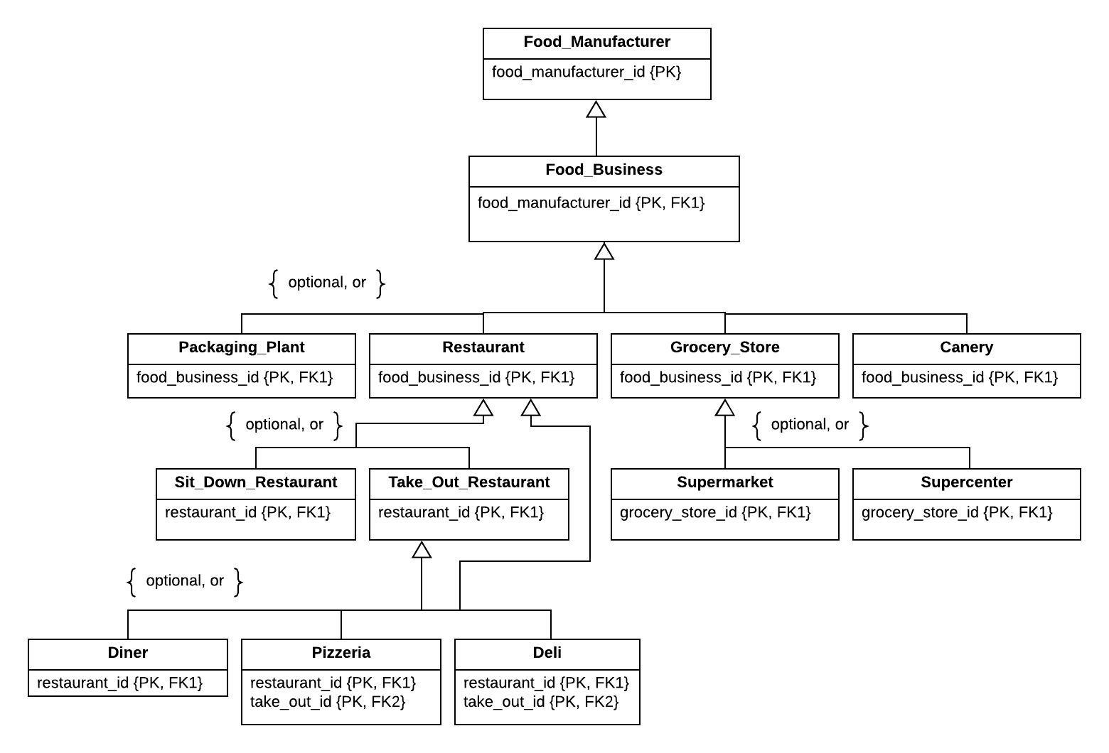

Your submission will be evaluated according to the following grading rubric.

|  |  |  |  |
| --- | --- | --- | --- |
|  | **Grade** | **Qualities Demonstrated by the Assignment Submission** | **Grade Assigned** |
| **Content (70%)**  **Measures the quality of the content in the assignment** | A+ ➔ 100 | The content demonstrates exceptional understanding of all relevant subject matter and its inter-relationships. All major relevant issues are thoroughly covered, and all content is very focused and on-topic. There is no known way to improve the content, and there are absolutely no technical or coverage errors present. |  |
| A ➔ 96 | The content demonstrates exceptional understanding of all relevant subject matter and its inter-relationships. All major relevant issues are thoroughly covered, and all content is very focused and on-topic. At most one insignificant technical or coverage error may be present |
| A- ➔ 92 | The content demonstrates deep understanding of all relevant subject matter and its inter-relationships. All major relevant issues are covered, and all content is on-topic. |
| B+ ➔ 88 | The content demonstrates understanding of all relevant subject matter and its inter-relationships. Almost all major relevant issues are covered, and the content is at least reasonably on-topic. |
| B ➔ 85 | The content demonstrates understanding of most relevant subject matter and its inter-relationships. Almost all major relevant issues are covered, and all content is at least reasonably on-topic. |
| B- ➔ 82 | The content demonstrates moderate understanding of much relevant subject matter and its inter-relationships. There is reasonable coverage of major relevant issues, and the content is at least reasonably on-topic. |
| C+ ➔ 78 | The content demonstrates some understanding of relevant subject matter and its inter-relationships. Some major relevant issues are covered, and at least some content is on-topic. |
| C ➔ 75 | The content demonstrates understanding of a small portion of the relevant subject matter and its inter-relationships. Some major relevant issues are covered, and at least a small portion of the content is on-topic. |
| C- ➔ 72 | The content demonstrates little understanding of and insight into the relevant subject matter and its inter-relationships. A small portion of the major relevant issues are covered. The focus of the content may be off topic or on insubstantial or secondary topics |
| D ➔ 67 | The content demonstrates almost no understanding of or insight into the relevant subject matter and its inter-relationships. Almost none of the major relevant issues are covered, and the content may be almost entirely off-topic. |
| F ➔ 0 | The content demonstrates no understanding of or insight into the relevant subject matter and its inter-relationships. No major relevant issues are covered, and the content is entirely off-topic. |
| **Exposition (30%)**  **Measures how well the content is expressed** | A+ ➔ 100 | The presentation of all ideas and designs is exceptionally clear and persuasive; the entire submission is exceptionally organized. There is no known way to improve the clarity or organization of the submission. |  |
| A ➔ 96 | The presentation of all ideas and designs is exceptionally clear and persuasive; the entire submission is exceptionally organized. There may be at most one insignificant way to improve the clarity or organization of the submission. |
| A- ➔ 92 | The presentation of all ideas and designs is very clear and persuasive; the entire submission is very organized. |
| B+ ➔ 88 | The presentation of all ideas and designs is clear and persuasive; the entire submission is organized. |
| B ➔ 85 | The presentation of most ideas and designs is clear and persuasive; most of the submission is organized. |
| B- ➔ 82 | The presentation of most ideas and designs is generally clear; most of the submission is reasonably organized. |
| C+ ➔ 78 | Some parts of the submission are hard to understand; some parts are disorganized. |
| C ➔ 75 | About half of the submission is hard to understand; about half is disorganized. |
| C- ➔ 72 | Most parts of the submission are hard to understand; most parts are disorganized. |
| D ➔ 67 | Almost all of the submission is hard to understand and disorganized. |
| F ➔ 0 | The entire submission is hard to understand and disorganized. |